Section President’s Message  March 2017  by John Kilps, P.E., M.ASCE  President, ASCE San Diego Section | 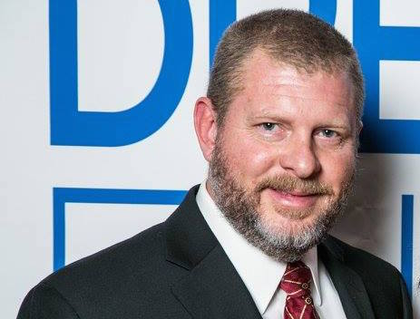

The much anticipated blockbuster movie event has arrived! Dream Big: Engineering Our World is now playing at the Fleet Science Center IMAX Theater in Balboa Park. The movie illustrates the compassion that engineers have in their projects, big and small, and how engineers shape our world. ASCE worked on this project in partnership with MacGillivray Freeman Films, and the Bechtel Corporation. The movie is a “must see” for all engineers.
A special movie premier event was held here in San Diego on Friday, March 3. Local engineers, managers, young professionals, students, and young children gathered to celebrate the event. More than 350 people attended the event, featuring guest speaker Assemblymember and former San Diego City Councilmember Todd Gloria. Assemblymember Gloria said it was fitting the movie premier event was in Balboa Park, the site of the Panama-California Exposition 100 years ago in 1915. San Diego is fortunate to have Assemblymember Gloria, who understands the importance of infrastructure to our community. The Panama-California Exposition is an example of how city leaders and engineers “dreamed big” to construct Balboa Park and host the international event. Today examples of engineers that dreamed big are evident throughout San Diego. Many of those examples are underground and unseen, such as aqueducts, pipelines and foundations. Engineers continue to dream big today, and given the challenges that face us, must continue to dream big into the future.
A BIG thank you to event chairperson, Kimberly Wender, and all the committee members that helped make the San Diego movie premier event very special.

