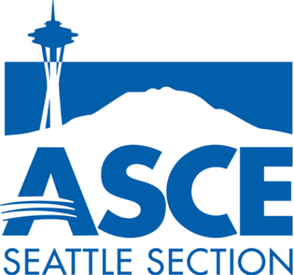

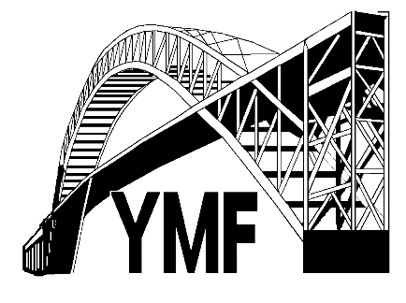
AMERICAN SOCIETY
OF CIVIL ENGINEERS

SEATTLE SECTION
YOUNGER MEMBER FORUM

www.seattleasce.org

2019 ASCE SEATTLE YMF

SCHOLARSHIP APPLICATION

General Information: The American Society of Civil Engineers (ASCE) was founded in 1893. Seattle area ASCE members under the age of 35 make up the Younger Member Forum (YMF), a group focused on networking, community service, student outreach, and professional development. The Seattle Section YMF has been raising money since 2004 to establish a scholarship program encouraging students to pursue a career in engineering. A scholarship of up to $1,000 will be awarded in the name of the Seattle Section Honorary Members of ASCE. The award will be presented at the May 2019 Seattle Section ASCE dinner meeting in Seattle. Dinner will be provided for the winner and up to two guests.

Eligibility: Qualified applicants must:
- be Seniors in High School
- show proof of acceptance to a 4-year institution
- be pursuing a field related to math, science, or engineering

*Applicants that have participated in a Popsicle Stick Bridge Competition will receive bonus points!

Note: The easiest way to fill out the scholarship form is to enter text directly using this document.

Contact Information:
Full Name: Date of Birth: / /
Permanent Address:
Telephone Number: ( ) - Student’s Email:
Education Information:
Name of High School:
Graduation Date: / / GPA (4.0):
Years Competed in the YMF Popsicle Stick Bridge Contest: ☐2019 ☐2018 ☐2017 ☐2016
Name of College/University Student plans to attend:
Expected Major:
Clubs/Organizations/Teams/Employment: (Up to 5)
1. Name of club/organization/team/employer:
Title/Position: Start Date: End Date:
Describe participation and time commitment:

2. Name of club/organization/team/employer:
Title/Position: Start Date: End Date:
Describe participation and time commitment:

3. Name of club/organization/team/employer:
Title/Position: Start Date: End Date:
Describe participation and time commitment:

4. Name of club/organization/team/employer:
Title/Position: Start Date: End Date:
Describe participation and time commitment:

5. Name of club/organization/team/employer:
Title/Position: Start Date: End Date:
Describe participation and time commitment:

Community Service: (Up to 3)
1. Name of activity:
Title/Position:
Start Date: End Date: Total Hours:
Describe participation:

2. Name of activity:
Title/Position:
Start Date: End Date: Total Hours:
Describe participation

3. Name of activity:
Title/Position:
Start Date: End Date: Total Hours:
Describe participation:

Essay Questions:
Choose 2 of the 3 questions to answer (250 words or less for each answer).
- What was most rewarding about your participation in the Seattle YMF Popsicle Stick Bridge Contest? What could the Seattle YMF do to make the competition better?

- How has engineering impacted your life? Describe an event, a person, and/or an idea/system that has done so.

- Describe a problem you foresee being a big issue for human society in the near future (during your lifetime) and provide insight and/or engineering solutions that could be used to either fix or treat the problem.

Application Instructions:

Complete Scholarship Application should include:

1. An official high school transcript (copy acceptable),
2. Completed scholarship application form,
3. Proof of acceptance to a 4-yr college/university (can send later if not available by April 3, 2019), and
4. One letter of recommendation from a non-family member.

Submit completed application via e-mail to ymf.scholarship@gmail.com by Wednesday, April 3rd, 2019, or by mail postmarked by Thursday, April 4, 2019, to:

Seattle ASCE YMF
c/o Wayne Chang
999 3rd Avenue, Suite 3200
Seattle, WA 98104

Contact Wayne Chang at ymf.scholarship@gmail.com for more information.

Scholarship Timeline:

April 4, 2019 Applications due
April 17, 2019 Announce winner
May 8, 2019 TBD Present award at the May ASCE Section Meeting in Seattle

