Seattle Section
American Society of Civil Engineers
R. H. Thomson Memorial Scholarship Program
Scholarship Application - 2020
Please complete all sections of this application and mail to:
Michael D. Harney
c/o Shannon & Wilson, Inc.
400 North 34th Street, Suite 100
Seattle, WA 98103

Or by e-mail to mdh@shanwil.com

Date of application: _________________________
Name: __________________________________________________ Age: ________________
Present address: ________________________________________________________________
________________________________________ Phone: _________________
High school graduated from: ______________________________________________________
Address: ___________________________________________________ Zip: _________
Home address at time of graduation from high school: ____________________________
Birthdate: ___________________________________ Citizenship: _______________________
Parent/Guardian: _______________________________________ Phone: _________________
Address: ________________________________________________________________
School now attending: _____________________________________________________
School expecting to attend next year: __________________________________________
Current school year (circle one): H.S. Senior Freshman Sophomore Junior Senior Grad
Previous junior college, college, or university attendance: course of study; degree, if any:
_______________________________________________________________________________
Current grade point average: ___________________

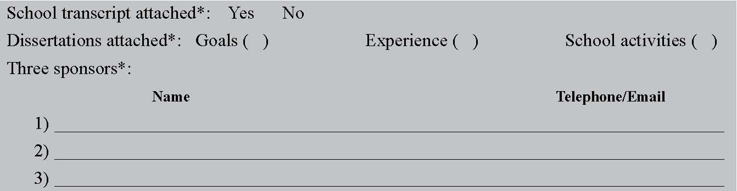
* These items are required elements of the application, including letters of recommendation from the sponsors. The sponsors are requested to write a letter of support as outlined in the Scholarship Program description.

