Maine Section of American Society of Civil Engineers
Technical Seminar - April 14, 2022

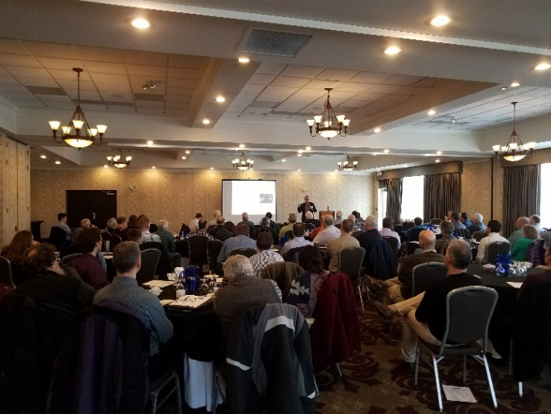
This year’s topics include:
- Pretty Good House: A Guide to Creating Better Homes
- A Case Study for Geotechnical Asset Management
- PFAS in the Environment
- Ferland Engineering Education & Design Center
- Navigating the Complexities of Urban Excavation
- Graham Road Landfill: From Cradle to Grave
- Innovations in Geomatics
- Stream Smart Crossings
Earn 7 PDHs for less than $25/PDH!

Schedule:
This year’s seminar will be held in the 4,375 SF Grand Ballroom to allow for social distancing.
7:30am – 8:00am: Registration and Breakfast Buffet
8:00am – 12:00pm: Speakers
12:00pm – 1:00pm: Lunch Buffet
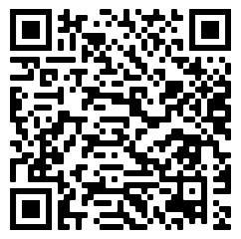
1:00pm – 4:00pm: Speakers
4:00pm – 5:00pm: Happy Hour with Cash Bar

Price:
$130 Government/ Municipal Officials (before 4/7)
$150 Maine ASCE Member (before 4/7)
$175 Non-Members and Late Registration (after 4/7)
$60 Students, Retirees, Life Members, & Unemployed Members

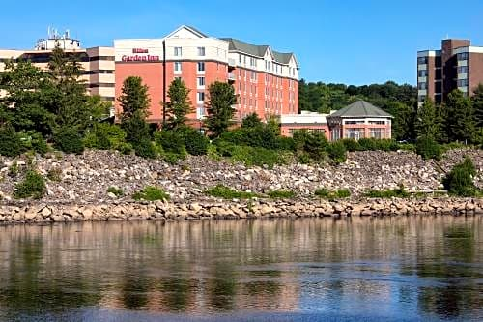
Registration:
- Follow the Eventbrite link in the Informant email, or
- Hold your camera up to the QR Code above

Location:
Hilton Garden Inn Auburn Riverwatch
14 Great Falls Plaza
Auburn, ME 04210

Questions?
Email Cece Walton – cwalton@vhb.com
Hilton Garden Inn Auburn Riverwatch

If you are interested in sponsoring a table, please complete the following Sponsor Form.
Maine Section of American Society of Civil Engineers
Technical Seminar - April 14, 2022

Sponsor Form

Sponsorship Amount: $250

The name of the sponsoring organization will be displaced on a table, and
we welcome organizations to bring a free-standing banner to display for the duration of the seminar! Sponsoring companies will also receive one free registration.

Sponsoring Organization:

Sponsor Contact

Name:

Email:

Phone:

Please make checks payable to Maine ASCE
Sponsorship payment will be accepted at the meeting
We reserve the right to invoice no-shows

** Email this completed form to cwalton@vhb to receive a promo code for one (1) free registration

Questions?
Email Cece Walton – cwalton@vhb.com

